1. 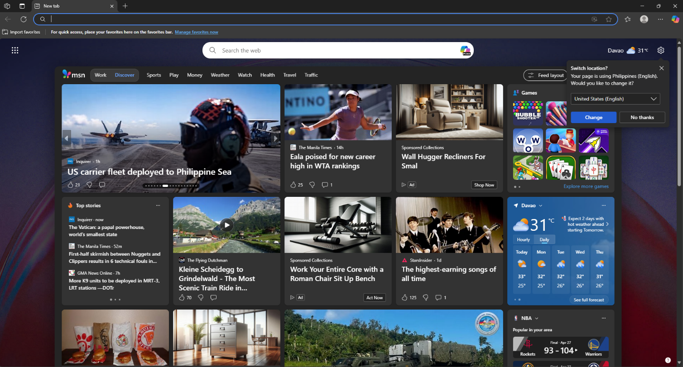**Microsoft Edge UI**
2. 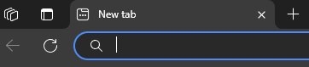**Parts**



Enhance Video button, and Add to Favorites button

Workspace button, Tab actions button, Current Tab, search bar.

Favorites button, Profile menu button, Settings button, and Copilot AI button

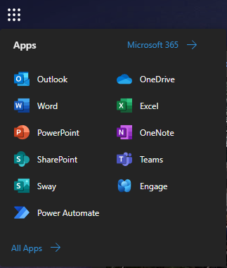

Apps window that leads to various google apps. Must be clicked to open and can’t be customized.

The design base as ha good foundation, but parts of the UI could be rearranged and some can be removed in order to make the experience more intuitive with less button presses, more important functions can be easier to see, and overall more new user friendly.

1. **New design**

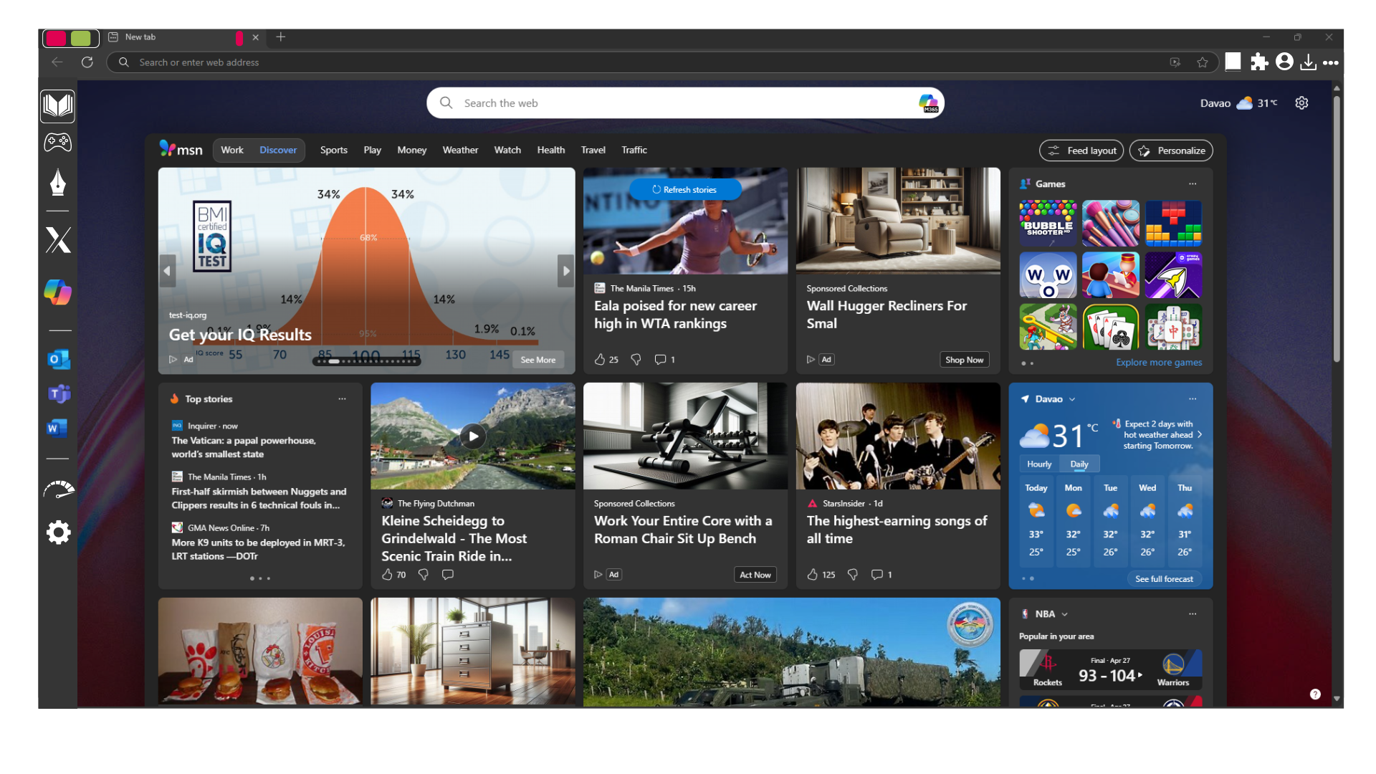

My enhanced UI features more intuitive button placement, as well as some features to enhance navigation. The top right I replaced with a bookmark / open favorites button, an extension button, kept the profile button, added a downloads button, and moved the main menu button. This replaces the copilot button which would not be used by new users. Then at the top left, instead of the workspace button and tab actions, it would be a space for tab groups using color for organizing the workspace. And finally, a new sidebar that holds buttons. It would contain the workspaces for easy access, quick select buttons for popular use cases such as social media or AI. The apps window would be moved to the sidebar as well for accessing the ones you frequent. This sidebar would also be able to be edited so that it can feature your favorite apps, workspaces, and settings to be easily found. Overall it would be easier to navigate and understand compared to the old UI.